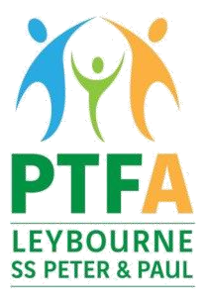
Registered Charity
No 1182596

Dear Parents/Guardians
PTFA School Disco – Friday 13 October 2023
The PTFA are looking forward to welcoming the children to the school disco on Friday 13th October in the school hall.
YR R and KS1: 3:30pm – 4:30pm
KS2: 5pm – 6:15pm
The entrance cost is £5 per child and is payable in advance via the Sum Up shop.
Please complete the below form and return to the school office by Wednesday 11 October.
……………………………………………………………………………………………………………………………………………………… 
PTFA School Disco Emergency Contact Form
Child’s Name________________________________________________________________

Year_______________________________________________________________________

Emergency contact name______________________________________________________

Relationship to child__________________________________________________________

Emergency contact number____________________________________________________

Name of person collecting on the night __________________________________________

Parent Email address (please ensure that this email is the same as that used for your payment)

___________________________________________________________________________

